BANDING
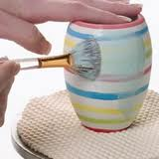
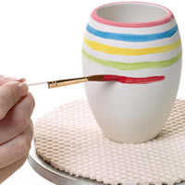

Definition:
Bands are lines marked around circular ceramic utensils, plates, jars or lids using any method of decoration which can be applied at all stages of manufacture. Banding is the action of marking a band.

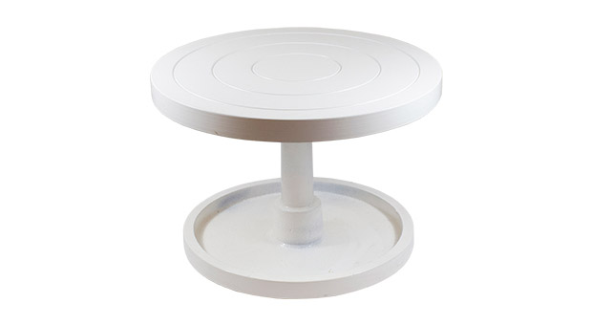
Tools:
Banding wheel—This is a table wheel that has
A long stem controlling the speed and
direction of the pot.

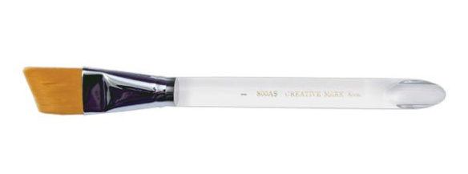
Brushes----Mop or angular watercolor

Slip trailing brushes and bottles
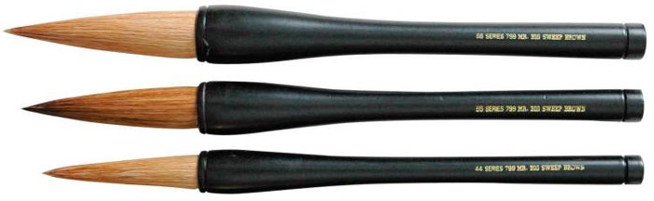

Techniques or Helpful Hints:
- The stain or under glaze should be the consistency of milk. If it is too runny it will drip and if it is too thick it will leave lap lines.
- You may add more water to the stain or under glaze to create a graded wash, as in watercolors.
- Apply your colors lightest to darkest.
- Always pull your brush forward horizontally in the direction of the spin to finish a line or to get more glaze or stain. If you just lift your brush up from the bisque ware during a line, it will leave a thick vertical line.

On Wet Clay: Use slip, mason stains, iron oxides
On Greenware: Use under glazes, glaze, iron oxides.
On Bisqueware: Use underglazes, glazes, acrylics, stains.

BURNISHING

Burnishing is a technique used to polish clay to a bright sheen without the use of glaze by compressing the clay particles together with a polished stone or the back of a spoon. Various types of clay can be used, but it should be a fine clay and grog-free. Rough clay with grog or sand can scratch up the surface of your piece.

Burnishing works best on leather hard clay. Keep in mind that forms that have sharp angles or elaborate decoration will be difficult to burnish.
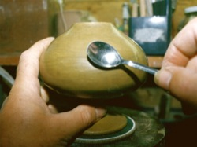
Materials:
- A polished stone or the back of a spoon
- Vegetable oil
- Plastic grocery bag (optional)

Step 1: Choose a lubricant such as vegetable oil or vegetable shortening to coat the piece. Water can be used for this step, but keep in mind that it will weaken the clay. Apply the oil only to the area that you are working on. You can also use terra sigillatta.

Step 2: Using the stone or the back of a spoon, rub the surface of the piece in circular motions, using a fair amount of force, but not so much that you break the piece. Rub the surface until you achieve a desired sheen. This process can take several hours depending on the size of the piece. You can also use a grocery bag wrapped over your finger to do a final burnishing with your hands. Burnished pots should be low-fired and do not need any final glaze.

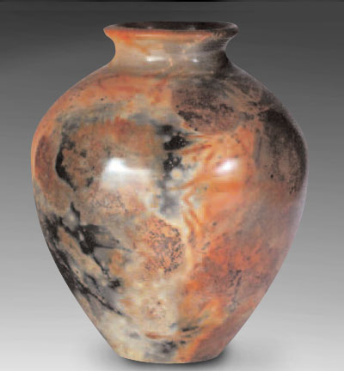
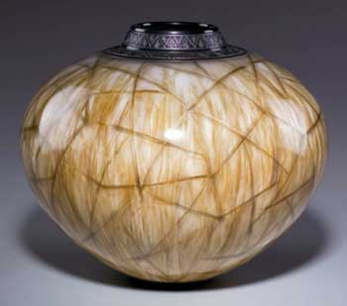

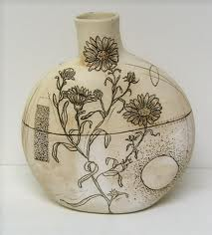
Mishima

What is it?
Mishima is a technique of inlaying slip, underglaze, or even clay into a contrasting clay body, the main clay body of the pottery piece. This technique allows for extremely fine, intricate design work with hard, sharp edges that can be difficult to reliably replicate in any other way.

A History:
Mishima is a city in Shizuoka Prefecture that boasts splendid views of Mount Fuji and is known chiefly as a gateway to Hakone and the Izu Peninsula. As far back as 1636, there was a certain calendar published at the Grand Shrine of Mishima (Mishima Taisha) written in little squiggly kanalines. Because the "rope curtain" designs of 15th-16th century Korean Punch'ong stoneware resembled the lines of the calendar, works of this pattern came to be known as Mishima. The Mishima name may be 17th-century, but the style itself goes back to the Koryo Period (935-1392) when bowls decorated in this way were known as Korai-jawan or Korai tea bowls. These were also inlaid with various motifs such as floral and animal depictions. A potter would incise the design in the body, fill it in with contrasting colored clay or slip and then cover it with a transparent glaze. This technique peaked in Korea in the 12th-13th-century Koryo celadons, deemed "first under heaven." It's also referred to as zogan.
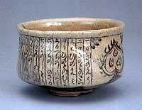
Edo Period chawan with calendar motif
Tools Needed:
Colored Slip
incising tool, mishima tool, or something sharp to cut small lines into leather hard clay
Bulb, syringe, fine tipped bottle, or brush

Process:
1. On leatherhard ware, draw a design with a needle tool or pencil.
2. Once design is complete, cut the lines to create a groove with the tool of your choice. You could use any number of tools such as pencils, sgraffito tools, loop and ribbon tools, small sticks, and so on.
3. Next using a bulb, syringe, fine tipped bottle, or even a brush, fill the inlaid design with the colored slip of your choice.
4. Once it is dry, you can use any number of different techniques to scrape away the excess slip. The most common is to use a metal rib tool or sponge to wipe away and clean it up.

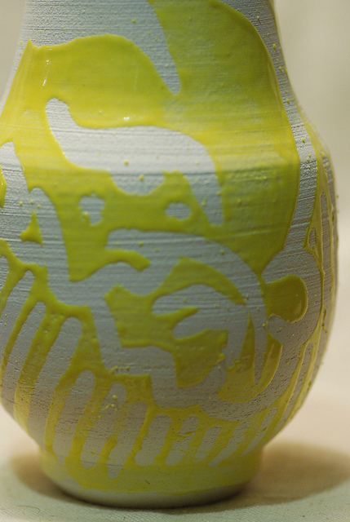
Resist
Decorating technique where resist materials (Wax, Crayon, Paper, Tape) are applied to prevent glaze from adhering to certain areas.

The options are many when it comes to creating decoration on your pottery with resists.

There are many types of resists available that are designed to work on both greenware and bisque ware, including wax and latex. there are also many options involving repurposing products and materials such as beeswax, stickers, tape, paper, acrylic medium, crayons, lipstick, Vaseline, and more!
The first thing to keep in mind when using any type of resist is whether or not it can be fired. Wax can be fired off in your kiln, while latex, paper, tape, etc., should be removed before firing because as they burn, they can carry and deposit glaze onto kiln shelves or other pots. Kilns must be well ventilated when firing any type of resist.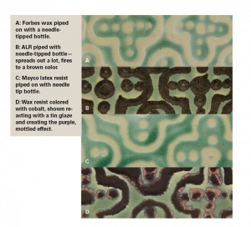

Wax Emulsion Resists
Sources: Forbes (water based), Mobil (oil based), Laguna Mobilicer-A, Wax-On, Amaco Wax Resist, Mayco Wax Resist, Continental Clay Wax Resist, Aftosa black wax resist, Duncan Wax Resist
Pros: Wax was easy to brush, dip, pour, spray, pipe (had to use tiny tips on a squeeze bottle to avoid too much wax running), easy to wipe off the pot, resisted glazes beautifully, and is easy to spot. We added food coloring to our wax resist to create a more noticeable mark on all clay bodies. Ceramic colorants (oxides and stains) can also be added to the wax to create interesting surface effects after the firing. To experiment with this type of mark making, try the following recipes:Mix 1 teaspoon iron oxide with 1 teaspoon Gerstley borate and a touch of water to blend. Then add 6 to 8 tablespoons of wax resist and thin as necessary to make a pretty brown wax.Mix 1 teaspoon stain (I used black Mason stain) with 1 teaspoon Gerstley borate and a touch of water to blend, then add 6 to 8 tablespoons of wax resist and thin as necessary to make a beautiful black wax.Mix ½ teaspoon cobalt carbonate with 1 teaspoon Gerstley borate and a small amount of water to blend. Then add 6 to 8 tablespoons of wax resist and thin as necessary for a blue wax.Blends of oxides or stains can make some great colors: rutile and iron produce an orange surface similar to a soda firing.
Cons: When you make a mistake, the wax must be fired off in order to remove it, although some wax emulsions can occasionally peel off between glaze layers. Wax emulsions handle differently when doing tasks like screenprinting, slip trailing, or sandwiching (layering wax between glazes to allow patterns to be formed with overlapped glazes). It’s important to find a wax you like to work with and one that works for you.
Latex Resist
Sources: Amaco Rubber Latex, Ceramic Shop Wax Off, Liquid Frisket, Aftosa Liquid Latex
Pros: Easy to brush (depending on the brand), and easy to peel off. You can easily apply latex over bisque and peel off to glaze that area or leave it alone. This makes glazing in the resisted area possible, where with other resist methods, you might need to fire first. With latex, you can immediately start glazing with your next color.
Cons: Sometimes thick glazes will cover the latex, making it hard to find and peel off. Firing latex can result in glazes flaking during the firing. Flakes can ruin shelves or other pots. Piping can be a challenge because latex can form bubbles. Note: People with latex allergies should not use this product.
Artistic Line Resist
Pros: Brushes and screens well, and pipes very well. Very versatile and can be fired at a variety of temperatures. Useful for cuerda-seca style work. Similar to the oil-based decal mediums and makes a great decal when brushed or screened onto decal paper.
Cons: Doesn’t resist brushed, sprayed, or dipped glazes well. Surface is wipe-able but not as much as a traditional wax resist. Stains the skin, has a strong odor, and must be used with a respirator fitted with a vapor filter, and preferably used outside or with a fan. When piping glazes, spreading occurred when we fired to cone 6. This resist is colored so you can’t use it if you want your resisted area to be the color of your clay—line work will be a metallic brown at cone 6, black at cone 04.
Clean Up
In general, clean up is time consuming with all of these products. Take care of your brushes, cleaning them as quickly as possible after resist use. Some people swear by dipping the brush in Murphy’s Oil Soap before using waxes and cleaning brushes with Shout or mineral spirits afterward. Use a separate set of brushes when using any type of resist. Clean your bottles, trays, and work area as soon as you finish—dried wax or latex in a bottle is no fun and any stray globs can easily find their way onto your pots.
Source

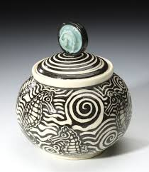
Sgraffito
What is it?
Sgraffito is a decorating technique produced by applying layers of color or colors (underglazes or colored slips) to leather hard pottery and then scratching off parts of the layer(s) to create contrasting images, patterns and texture and reveal the clay color underneath. The layer(s) of color can be underglazes or colored slips.

History:
The word “sgraffito” is Italian, its meaning being to “scratch, write or to mark“. Sgraffito is the technique of scratching an image through a coloured slip to reveal the body beneath. Sgraffito Pottery was once considered to be the vessels of kings. From the Byzantine emperors to the Russian czars, Sgraffito has been the earthenware for the “blue-bloods” of Europe’s finest houses. Although the technique is relatively simple, the process is time consuming and painstaking.

During the 16th century renaissance in Italy, Sgraffito was utilised in wall art, pottery decoration and canvas paintings. Sgraffito on walls has been used in Europe since classical times and its origins go back to Africa and Japan. It came to Europe through the Middle East. Because the Muslims were forbidden to eat from any metal wares, they had developed the decorative side of pottery to high degree. This also included the use of a sgraffito decoration. Both the North African potters and Spanish potters were imported into Italy to share their skills and techniques. During the Reconquista of Spain, Spanish Muslim potters fled to North Africa, and to Italy and Byzantium, where their knowledge merged with the techniques of local potters to create new and exciting styles of pottery for Renaissance patrons of art. The Muslim, or Moorish, artistic styles of Spain are described as Hispano-Moresque.

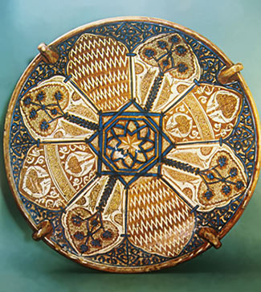

Tools Needed:
-Wire stylus tool, mini ribbon sculpting tools, or any tool that can carve an intricate design.
-Colored slip or glaze
-Leather hard clay

Hispano Moresque Brasero (Deep Dish)
from Valencia, Spain 1400 CE

Process:
1. Begin by painting ceramic ware with colored slip or underglaze.
2. Once the color is dry, carve out design carefully.
3. Fire greenware
4. After first firing, is the best time to put a clear glaze over the top.

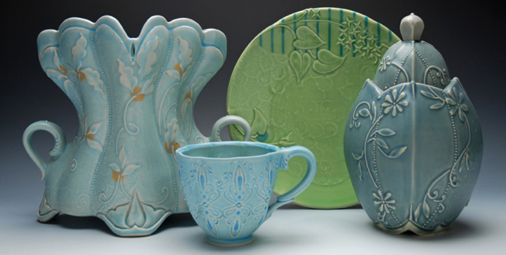

Slip Trailing
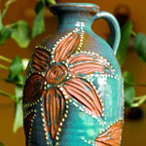
What is it?
Slip trailing is the process of applying a watered down clay body, known as slip, to a wet or leather hard project to create a raised pattern or design on ceramic work.

How do you do it?
To begin, create a project with enough surface area to add a slip design to. Slip can be applied to projects in a variety of ways. You can use squeeze ketchup bottles (like you use for a picnic or bbq) to create thick, heavy lines. To create a thinner line you may use small squeeze bottles with smaller tips (these can be purchased online for very cheap) Be sure that your nozzles are clean and that your slip is not too thick.
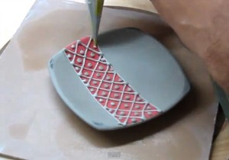
At the wet to leather hard stage, place the nozzle of your extruding device against the surface of your project and gently squeeze the slip out onto your project. Be sure that your slip is not too runny, it will drip if it is. (Pancake batter consistency is usually good) You can create intricate patterns and designs on the surface of your projects using slip.

Additions and Cool Things to Do!
Add mason stains to your slip to create fun colors and more visual interest.
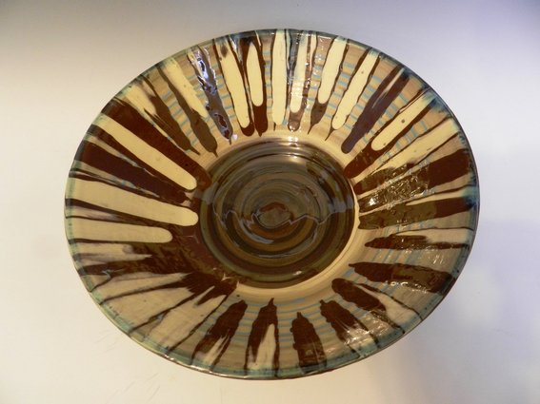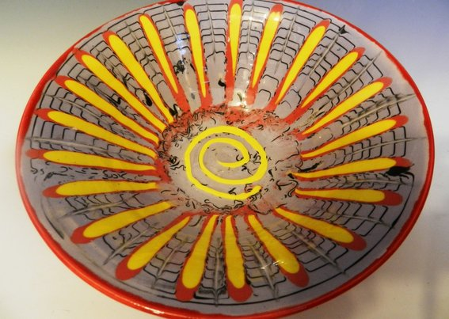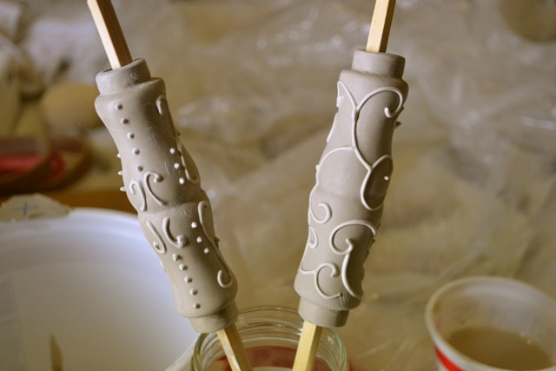

Band on the wheel using slip trailing and stains- The wheel rotation allows for straight lines and radial patterns to be made easily.

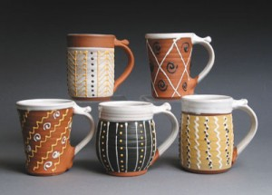
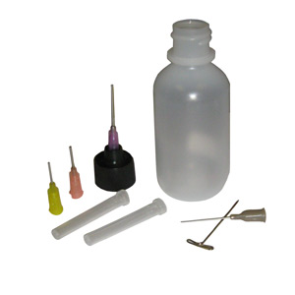
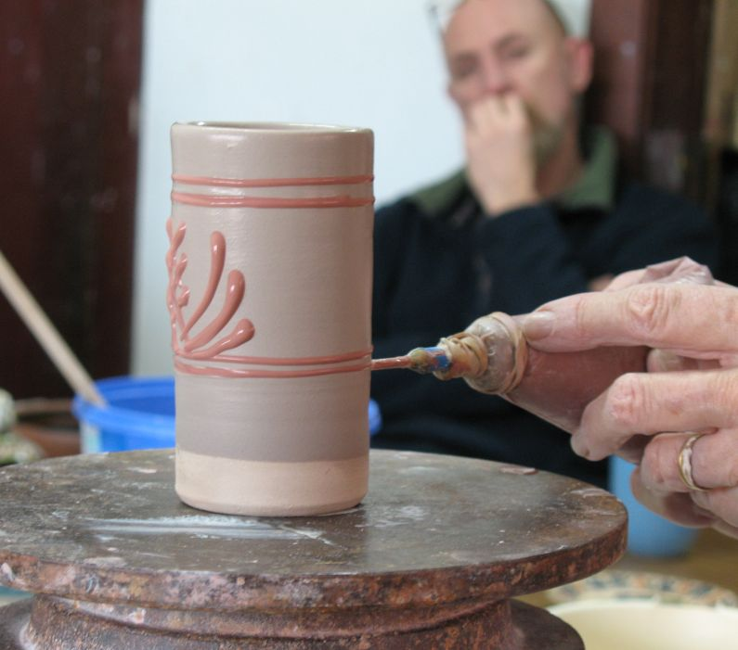

SPRAY GLAZE:

Spray glazing and under-glazing in 4 Easy Steps (2-4 coats)

• Step 1: Water glaze down and load (consistency should be like orange juice)
- Make sure no chunks because it will clog (use electric mixer to dissolve chunks, or glaze strainer to remove chunks)
• Step 2: Find your desired air pressure by testing on a piece of cardboard inside your spray booth (you want relatively low air pressure)
- If it’s too high air pressure can knock project over
- Too much air pressure can also make the glaze spray too hard and not stick to the project, if it’s too low, nothing sprays out
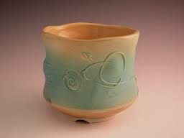
• Step 3: Use decorating wheel to spin project and apply thin even coats letting it dry in between
- Weighted decorating wheels keep the spin longer
- Its like spray-paint- if nozzle is too close or glaze goes on too thick, glaze will run

• Step 4: Switch glaze colors by cleaning out nozzle and refilling with new color.
- Clean nozzle by filling container with water and spraying out until only clear water sprays out
- Also clean out at nozzle at the end of each use so glaze doesn’t dry out inside nozzle and clog it
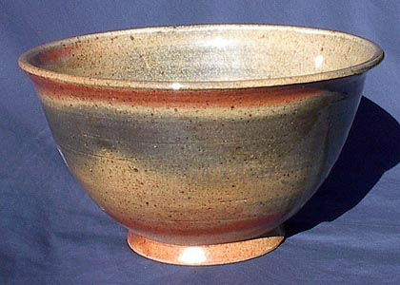
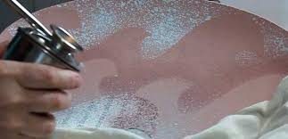

Most Supplies can be found at Harbor Freight (1-5)
Harbor Freight Store Locations:
Orem: 155 N. State St. Orem, UT 84057
West Jordan: 7046 S Redwood Rd Ste B, West Jordan, UT 84115
Salt Lake: 3470 S. State St, Salt Lake City, UT 84115
1. Spray nozzle (like for spray paint) $19.99-$79.99
http://www.harborfreight.com/catalogsearch/result?q=spray+nozzle
2. Portable air tank $25.99 5 (gal) / $35.99 (11 gal)
http://www.harborfreight.com/catalogsearch/result?q=compressed+air+tank
3. Air Hose $7.99 - $49.99 (depending on length)
http://www.harborfreight.com/catalogsearch/result?q=air+hose
4. Coupler $2.99
http://www.harborfreight.com/catalogsearch/result?q=coupler
5. Respirator (for dust) $1.29 - $23.99
http://www.harborfreight.com/catalogsearch/result?q=respirator
6. Spray booth
7. Weighted decorating wheels
Blick $28.95 http://www.dickblick.com/products/amaco-no-5-decorating-wheel/
Amaco $31.95 http://www.amaco.com/shop/product-549-decorating-wheel-no-5.html
Brickyard $21.49 - $190.00 http://www.brickyardceramics.com/acatalog/Decorating_Wheels.html

TRADITIONAL GLAZING

There are 3 types of glaze that we will be using: UNDERGLAZE (colored slip), REGULAR GLAZE, and DIP GLAZE

LOW-FIRE:
Underglaze: Can go on Bisqueware and Greenware. Underglaze is a colored slip so it shrinks with the clay during a bisque firing.

Low Fire glaze: Short fat bottles. Can ONLY go on Bisqueware. This glaze needs at least 3 coats.

Directions:
1. With these bottles, make sure the cap is on correctly, then shake the bottles. If you can’t get the bottle open run it under hot water for about a minute.
2. Only use 2-3 colors at a time. Make sure that each color is separated by at least 2 wells in the palette.
3. Write your specific colors that you use down on your sketchbook notes. A lot of colors look the same.
4. Paint 2 -3 layers, but in a systematic approach. As in, finish painting 1 entire layer before you start the second coat or you won’t be able to tell where you left off.
5. Don’t paint the bottom; anywhere on the project where it touches the table when you put it down should not be painted.
6. Don’t paint on the canvas, move the corner up so as to not get glaze on it.
7. Clean-up: All excess glaze gets poured back into the bottle. This is the most expensive part of ceramics, we don’t want to waste.

HIGH FIRE:
Dip Glaze: 5 gallon buckets; can only go on Bisqueware.

- Wax resist your project, ¼” up the side and bottom; wash the brush, and be sure to cap the wax.
- Mix the glaze to a thick consistency using the drill.
- Wash the drill
- Dip your project quickly being sure to coat it thoroughly.
- Wash off excess glaze off of the wax resist.
- Cap the glaze bucket, clean up any mess you left including the dipping tongs.

